Name : Shashikant kanole

Prn = 220940520087

Question1 :-

import org.openqa.selenium.chrome.ChromeDriver;

public class Question1 {

ChromeDriver driver;

public void openbrowser() {

System.*setProperty*("web.chrome.driver","C:\\Users\\Shashi\\eclipse-workspace\\chromedriver.exe");

driver = new ChromeDriver();

String url = "https://www.google.co.in/";

driver.get(url);

driver.manage().window().maximize();

//driver.close();

}

public static void main(String[] args) {

Question1 obj = new Question1();

obj.openbrowser();

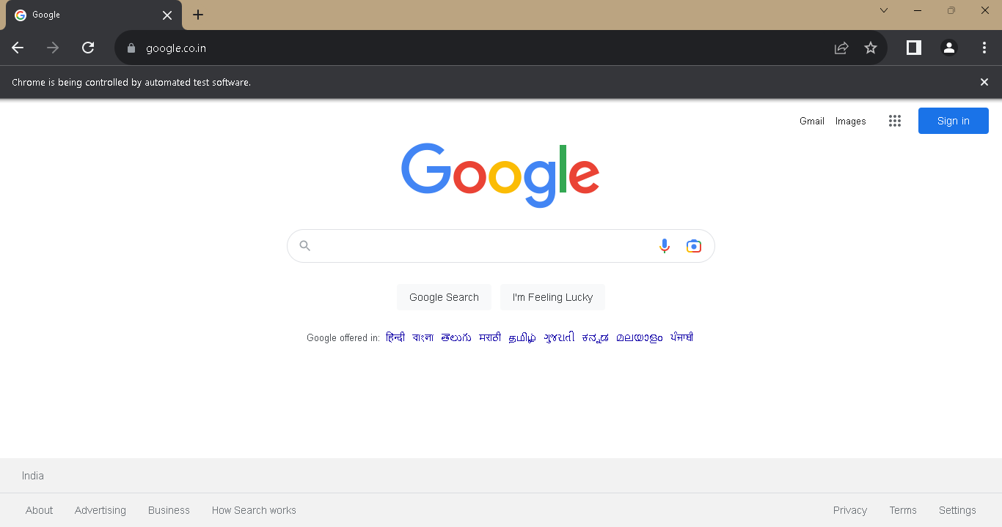}

Question 2 :-

import org.openqa.selenium.chrome.ChromeDriver;

public class Question2 {

ChromeDriver driver;

public void openbrowser() {

System.*setProperty*("web.chrome.driver","C:\\Users\\Shashi\\eclipse-workspace\\chromedriver.exe");

driver = new ChromeDriver();

String url = "https://www.google.co.in/";

driver.get(url);

driver.manage().window().maximize();

//driver.close();

Question2 obj = new Question2();

obj.gotosignin();

}

public void gotosignin() {

System.*setProperty*("web.chrome.driver","C:\\Users\\Shashi\\eclipse-workspace\\chromedriver.exe");

driver = new ChromeDriver();

String url = "https://accounts.google.com/ServiceLogin?";

driver.get(url);

driver.manage().window().maximize();

}

public static void main(String[] args) {

Question2 obj = new Question2();

obj.openbrowser();

}

}

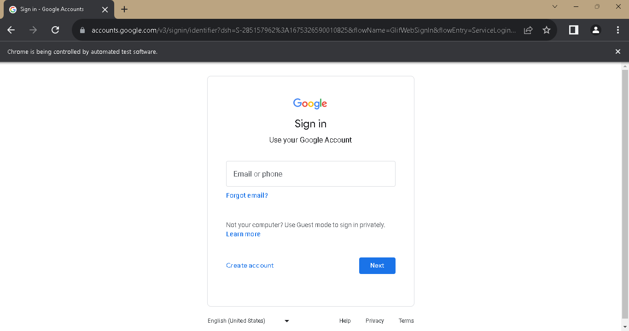Question3:-

import org.openqa.selenium.By;

import org.openqa.selenium.chrome.ChromeDriver;

public class Question3 {

ChromeDriver driver;

public void openbrowser() {

System.*setProperty*("web.chrome.driver","C:\\Users\\Shashi\\eclipse-workspace\\chromedriver.exe");

driver = new ChromeDriver();

String url = "https://www.google.co.in/";

driver.get(url);

driver.manage().window().maximize();

//driver.close();

Question3 obj = new Question3();

obj.gotosignin();

}

public void gotosignin() {

System.*setProperty*("web.chrome.driver","C:\\Users\\Shashi\\eclipse-workspace\\chromedriver.exe");

driver = new ChromeDriver();

String url = "https://accounts.google.com/ServiceLogin?";

driver.get(url);

driver.manage().window().maximize();

driver.findElement(By.*id*("identifierId")).sendKeys("sachinkanole116");

//driver.findElement(By.name("k77Iif")).click();

}

public static void main(String[] args) {

Question3 obj = new Question3();

obj.openbrowser();

}

}

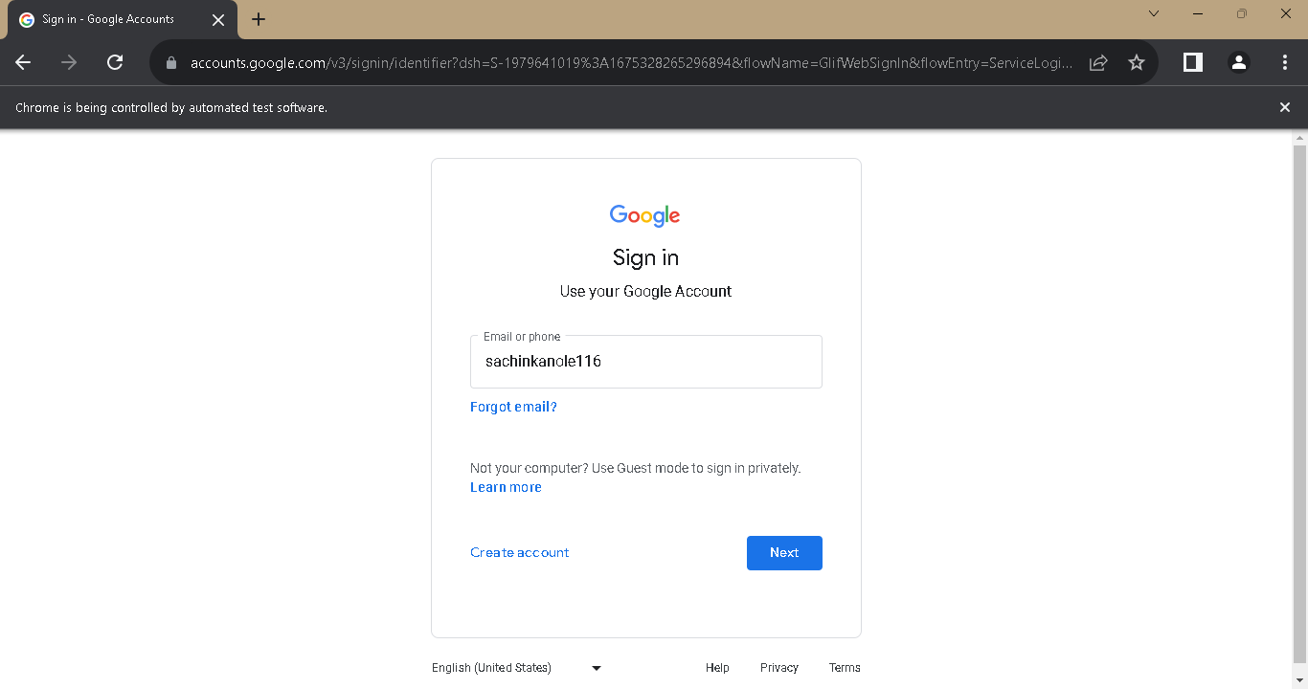

Question4:-

import org.openqa.selenium.By;

import org.openqa.selenium.chrome.ChromeDriver;

public class Question4 {

ChromeDriver driver;

public void openbrowser() {

System.*setProperty*("web.chrome.driver","C:\\Users\\Shashi\\eclipse-workspace\\chromedriver.exe");

driver = new ChromeDriver();

String url = "https://www.google.co.in/";

driver.get(url);

driver.manage().window().maximize();

//driver.close();

Question4 obj = new Question4();

obj.gotosignin();

}

public void gotosignin() {

System.*setProperty*("web.chrome.driver","C:\\Users\\Shashi\\eclipse-workspace\\chromedriver.exe");

driver = new ChromeDriver();

String url = "https://maps.google.co.in/maps?hl=en";

driver.get(url);

driver.manage().window().maximize();

}

public static void main(String[] args) {

Question4 obj = new Question4();

obj.openbrowser();

}

}

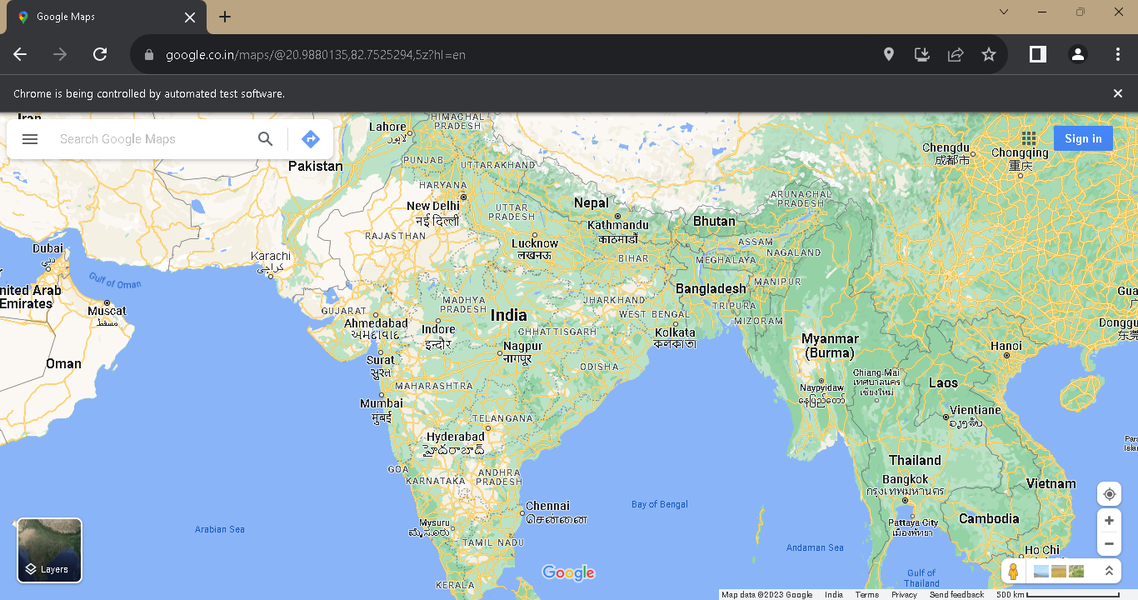

Question5:-

import org.openqa.selenium.By;

import org.openqa.selenium.chrome.ChromeDriver;

public class Question4 {

ChromeDriver driver;

public void openbrowser() {

System.*setProperty*("web.chrome.driver","C:\\Users\\Shashi\\eclipse-workspace\\chromedriver.exe");

driver = new ChromeDriver();

String url = "https://www.google.co.in/";

driver.get(url);

driver.manage().window().maximize();

Question4 obj = new Question4();

obj.gotomaps();

//driver.close();

}

public void gotomaps() {

System.*setProperty*("web.chrome.driver","C:\\Users\\Shashi\\eclipse-workspace\\chromedriver.exe");

driver = new ChromeDriver();

String url = "https://maps.google.co.in/maps?hl=en";

driver.get(url);

driver.manage().window().maximize();

driver.findElement(By.*id*("searchboxinput")).sendKeys("cdac");

driver.findElement(By.*id*("searchbox-searchbutton")).click();

}

public static void main(String[] args) {

Question4 obj = new Question4();

obj.openbrowser();

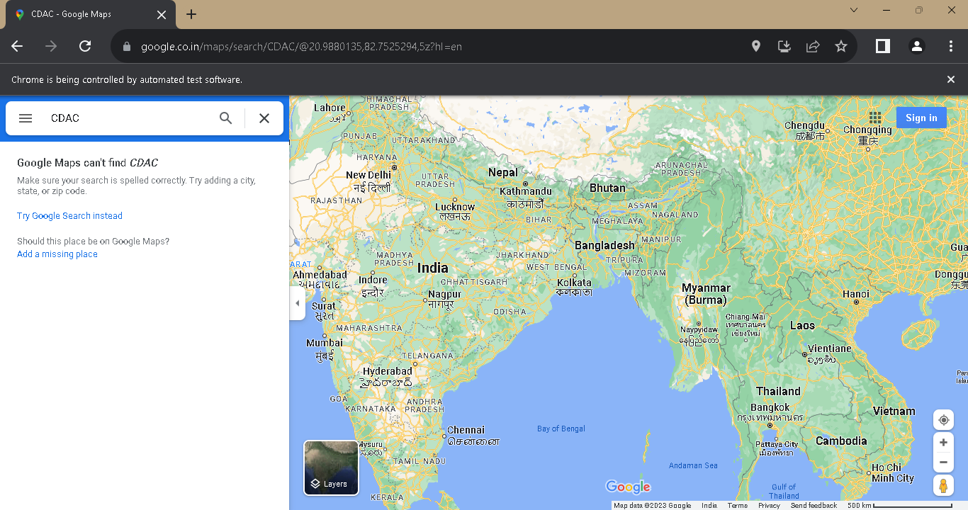}

}

**SectionII**

Question 1 :-